Carlow Triathlon 2017

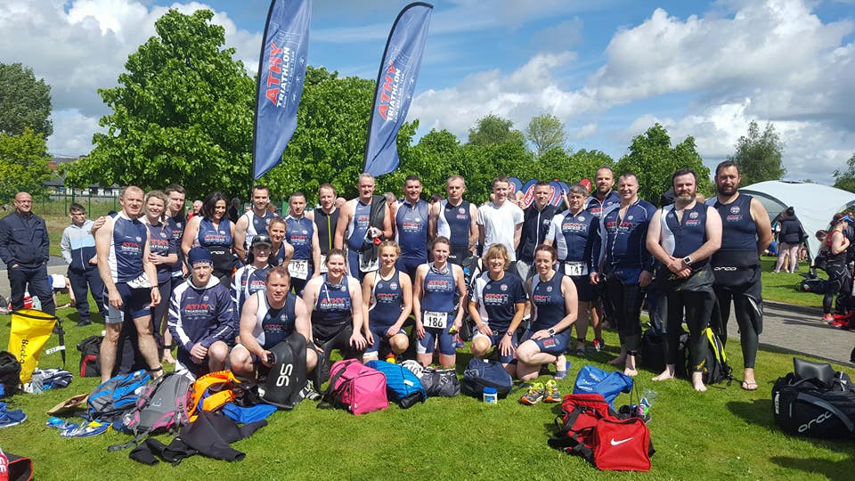

The Carlow Triathlon was earlier this year on the 14th of May and I am sure I speak for most of us, entering the Carlow Triathlon kick-starts the Triathlon season. When coming to the realisation last week that the Carlow Triathlon was THIS Sunday hit me like a ton of bricks!! All thoughts raced through my mind – You may get some more cycling practice you only been out twice! Ah sure I’ll be grand I did a good bit of running, that will surely help - wont it? (not too sure!)
On the morning of the Triathlon we go through the pre race ritual (well my Peadar does). He pumps up our tyres; he sprays the chains with what I assume is oil for lubricating the chain. Stick the stickers onto the seat, the bag, the helmet. Put our number tag onto our number tag holders and much more, ensuring we have the essentials in the bag our wetsuit, hats, goggles, tissue, powder, socks, Vaseline.
A friend of mine, a first timer asked me for advice on what to bring for the Transition area, so I suggested the above and explained the importance of talc powder for our feet/socks/runners. She texted me the morning of the race saying “Hi Maggie, sorry just a quick text, what do I need Vaseline for?”
“Your lips, of course!” I replied.
The Race took place at 12.30pm which is a bit late in the day I feel, I would have liked it to be a bit earlier. I tried to time my breakfast so that I have eaten 2 hours in advance of the race. We don’t want to get stomach cramps, do we? A bowl of porridge sprinkled with nuts & raisins, drizzled with some honey and a glass of beetroot juice! (well, If its works for Peadar……)

We set off at 11 to our neighbouring county, Carlow. When we arrived we could see parked traffic was afar back, Peadar drove on and we were very lucky to get a perfect parking spot right beside the footbridge, which brought us right into the hub of the Triathlon, the Carlow Park. The Carlow Park is the main location as for the Triathlon as all 3 sports starts and finishes there. This park area is a delightful amenity for all the family. It is modernised with a cobblestone bank walk, wonderful play area for children and lots of green lawns.
As we cross the bridge we were delighted to see two soaring banners with ATHY TRIATHLON CLUB right in the centre. This was a great idea (whoever thought of that) as it was easy for all of us to go to the one spot and meet our fellow club members, supporters and friends. There was a big crowd of us that morning. I cannot tell you how many but I say there was at least 40 of us from Athy! Viv will have statistics.
The sun was shining which was a blessing as the weather forecast gave rain! The atmosphere was full of excitement and anticipation as we commence onto the bank walk towards the swimming start position. I myself was in the last wave, wave 7. I am half sorry I put in a lengthy time onto the application form – you see last year I put 11 minutes and I was in wave 2/3 – BIG MISTAKE! As all the expert swimmers swam over me making me feel panicky! So I said I better tell the truth this year!
Off they go wave by wave leaving me on the side all by myself – Thank god for the lovely and number 1 supporter Trisha Mitchell who kept me company and gave me encouragement as I reluctantly step into the (Post nightfall rain) freezing cold river.

Once I climatised and started the swim I was grateful to be able to put my face into the water. I was delighted to have some rhythm in my swimming strokes, however they were more like ‘One, two breathe, one, two breathe’ I tried the ‘One, two, three, breathe but it made me feel dizzy. I was happy enough to carry on with my ‘one two breathe’ technique. I absolutely hate that turning point at the buoy, the nice fellow athletes you were casually chatting to before you got into the river soon became sea monsters as they bypassed that buoy!
Twenty minutes later I finished the swim and emerged onto the slip that was surrounded with lots of familiar faces and supporters Deirdre Walsh, Gemma Martin, Ethna Sourke, Coroline Howe, new member Sean Fitzpatrick!, to name a few….. They were deadly cheering us on!

I run onto the Transition area. Remember earlier I was saying how prepared I was? Well I knew something was missing! It took me a half hour (figure of speech!) to put on my new runners. Note for next time GET ELASTICISED LACES!

The bike, don’t talk to me about the bike!!
The route brought us straight out to Killeshin Road 10km of a climb. I found this very tough and gruelling as the road in front of me kept ascending. I could see all the familiar faces from Athy Triathlon Club speeding past me on their way back to the hub. God I wish I was travelling with them!
I tried with all my might to peddle those legs!! Keep peddling, keep peddling! Peadar and Pauric Kavanagh voice ringing in my head “Don’t Stop them legs peddling!” I was so glad when a girl cycling back tells me the 10km turning point is just around the bend. The cycle back to the Carlow Park was much easier as we are cycling downhill. What amazed me was how inclusive this event was, there was blind people cycling on a tandem bicycle, a paraplegics person cycling their bike with their hands.
Back to the transition area I dropped my bike and started my run. 2/3 done and now 1/3 to go! I have done some running training so I was confident that this shouldn’t be a bother to me and it wasn’t. It was a very enjoyable run along the winding river bank. I hoped to do the run in less than 30 minutes and I was disappointed to find that my running time was 31 minutes and 35 seconds. However this disappointment soon disappeared as I reach the finish line and seen the Athy Triathlon Club gang all cheering me on! This was the highlight of my day. This is why I love this club! The members are so supportive, enthusiastic encouraging and absolutely great fun! Even though Peadar’s lips were blue with the cold waiting for me!! Athy Triathlon Club is the best Triathlon Club in Ireland and I am so proud to be part of it.

